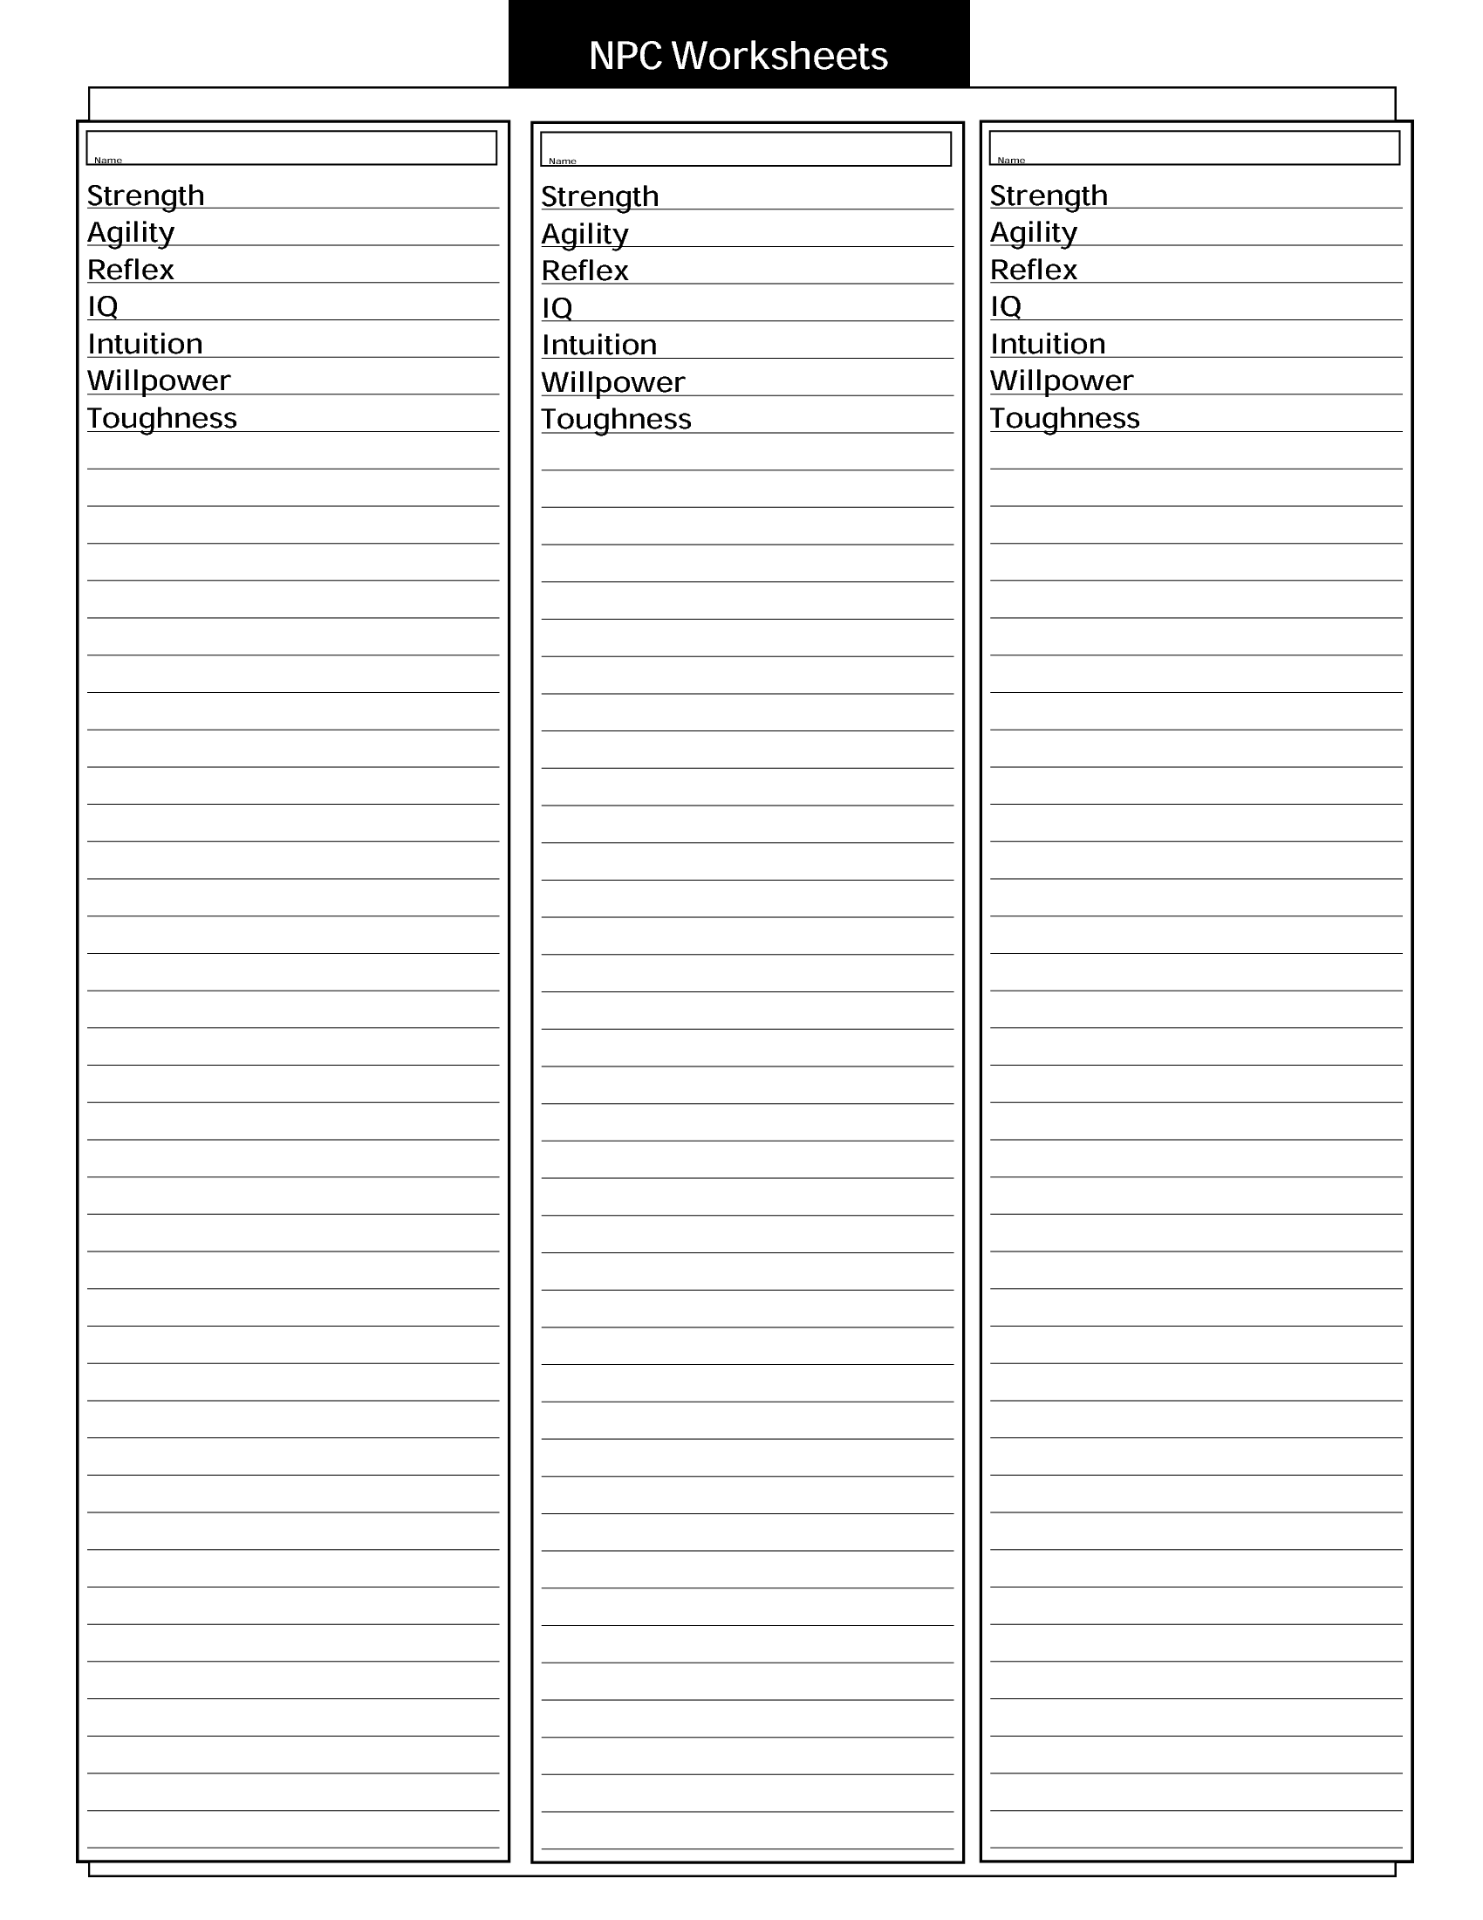

Awesome (10)

Above Average (6)

Above Average (6)

Exceptional (8)

Above Average (6)

Average (5)

Bullywug Twitchers

Bullywug Muckers

Bullywug Croakers

Average (5)

Above Average (6)

low (3)

Average (5)

Low (3)

Above Average (6)

Average (5)

Average (5)

Average (5)

Weak (2)

Above Average (6)

Weak (2)

Average (5)

Miniscule (1)

Average (5)

Weak (2)

Weak (2)

Miniscule (1)

Miniscule (1)

Defense

Defense

Combat

Combat

Defense

Combat

Weak (2)

Weak (2)

**Strengths:**

**Strengths:**

**Strengths:**

* **Swampwalk:** movement through mud difficult terrain is not affected.
* **Swimming:** swimming of rank Above Average.
* Poison Resist Strength of Weak
* Athletics rank of Incredible
* **Swampwalk:** movement through mud difficult terrain is not affected.
* **Swimming:** swimming of rank Above Average.
* **Swampwalk:** movement through mud difficult terrain is not affected.
* **Swimming:** swimming of rank Above Average.
* **Bully:** if a mucker does damage to a prone target, that target receives an additional below average stunning damage

**Weaknesses:**

**Weaknesses:**

**Weaknesses:**

* If this monster receives full damage from a lethal source, then the attacker can recover from a wound that is -1RS, if there aren't any, then no effect.
* If this monster receives full damage from a lethal source, then the attacker can recover from a wound that is -1RS, if there aren't any, then no effect.
* If this monster receives full damage from a lethal source, then the attacker can recover from a wound that is -1RS, if there aren't any, then no effect.

**Abilities:**

**Abilities:**

**Abilities:**

* **Poison cloud**: any character within 10 feet of the Croaker suffers a temporary -1RS to Strength, and Willpower until that character's combat "turn" is over.
* **Javelin (melee):** [AR=combat, DR= defense/reflex] damage=Lethal Above Average(6)
* **Javelin (ranged):** [AR=combat, DR= defense/reflex] damage=Lethal Above Average(6)
* **Spasmodic Hop:** Range = 55ft. [AR=combat, DR=defense/reflex] damage=Stunning Exceptional. Target gets -1RS to combat for one turn.
* **Poison cloud**: any character within 10 feet of the Croaker suffers a temporary -1RS to Strength, and Willpower until that character's combat "turn" is over.
* **Spear:** [AR=combat, DR= defense/reflex] damage=Lethal High(7)
* **Bullywug Rush:** roll on Fate chart to see if it can use (AR=Below Average, DR=Chaos Value) If can use [AR=Combat, DR=Willpower] damage=Stunning Exceptional. Target is knocked prone.
* **Poison cloud**: any character within 10 feet of the Croaker suffers a temporary -1RS to Strength, and Willpower until that character's combat "turn" is over.
* **Claw:** [AR=combat, DR= defense/reflex] damage=Lethal Average(5)
* **Foul Croak:** spews a 10ft conical burp of poison. [AR=reflex, DR=Toughness] damage=Weak poison.
* The Muckers will lead off their attack with Bullywug Rush, then move in to fight melee. If separation occurs between the Muckerand the player, then the Muckerwill once again lead the combat off with Bullywug Rush.
* The twitcher will engage with a javelin at range, from the comfort of a mud wallow. It will only engage with a player in melee combat if the player enters a mud wallow where it will have movement advantage b/c of its swampwalk.
* Spasmodic hop is only used if the twitcher thinks it can finish off the player.
* The Croakers will lead off their attack with foul croak, then move in to fight melee. If separation occurs between the Croaker and the player, then the Croaker will once again lead the combat off with the foul croak.

**Tactics:**

**Tactics:**

**Tactics:**